Software Requirement Specification

NHOM4-SRS-001

Version 1.0

**Revision History**

| Date | Version | Description | Author | Revised by |
| --- | --- | --- | --- | --- |
| 3/12/2018 | 1.0 | First version | Trần Minh VIệt | Vũ Công Hoàng |
|  |  |  |  |  |
|  |  |  |  |  |
|  |  |  |  |  |
|  |  |  |  |  |

Table of Contents

**1.** **Introduction** 4

**1.1** **Overview** 4

**1.2** **Scope** 4

**2.** **Functional Requirements** 5

**2.1** **Feature/Component #1: login page** 5

2.1.1 User Interfaces 6

2.1.2 Functional Requirements 6

2.2 **Feature/Component #2:** **Registration page** 8

2.2.1 User Interfaces 8

2.2.2 Functional Requirements 9

**2.3** **Feature/Component #3: Home page** 11

2.3.1 User Interfaces 11

2.3.2 Functional Requirements 12

**2.4** **Feature/Component #4: Detail page** 13

2.4.1 User Interfaces 13

2.4.2 Functional Requirements 14

**2.5** **Feature/Component #5: User info page** 15

2.5.1 User Interfaces 15

2.5.2 Functional Requirements 16

**2.6** **Feature/Component #6: Logout page** 17

2.6.1 User Interfaces 17

2.6.2 Functional Requirements 18

# **Introduction**

## **Overview**

This software supports users to view the phone on the online and can order the product.

## **Scope**

Demo version

Demo version is for display purpose only, not link to Database, not link to affiliated sites

Android OS: Android: OS 4.0.X to 6.0.X

Android screen resolutions: 480x800, 720x1280

Support screen orientation in landscape mode only

# **Functional Requirements**

## **Feature/Component #1: login page**

### User Interfaces

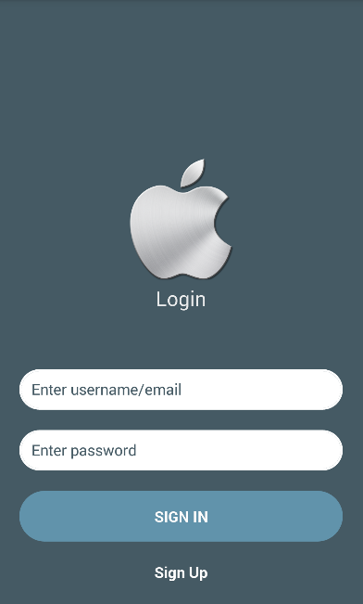

*Image1:* login page

### Functional Requirements

|  |  |  |  |
| --- | --- | --- | --- |
| **Item** | **Description** | **Action** | **Response** |
| login page | Include:   * 2 Button * 2 Text Input * Text * 1 Image | N/A | N/A |
| Button “sign in” | Log in successfully if correct account information | Click | Logged in successfully,  Switch to home page |
| Image | Contains the image of the application | N/A | N/A |
| Text Input  “User name ” | Allows the user to enter a login name | N/A | N/A |
| Text Input “Password” | enter password | N/A | N/A |
| Button “Sign up” | For customers who register without an account | Click | Go to the Subscriptions page, switch to Subscriptions  Page |

## **Feature/Component #2:** **Registration page**

### User Interfaces

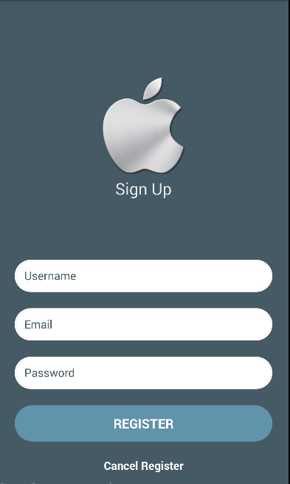

*Image2: Registration page*

### Functional Requirements

|  |  |  |  |
| --- | --- | --- | --- |
| **Name** | **Description** | **Action** | **Response** |
| Registration page | Include:   * 1 Image * 3 Text Input * 2 Button * Text | N/A | N/A |
| Text Input “Enter account name” | Enter account name | N/A | N/A |
| Text Input” Enter password” | Enter password | N/A | N/A |
| Text Input “Enter Email “ | Enter Email | N/A | N/A |
| Button “Registration” | Registration is successful if the correct information is registered | Click | When successful registration will be announced "Successful registration" |
| Button “Cancel Registration” | If you do not want to continue signing up for an account | Click | Go back to the home page |
| Text “Sign up“ | Name Sign up | N/A | N/A |
| Image | Contains the image of the application | N/A | N/A |

## 

## **Feature/Component #3: Home page**

### User Interfaces

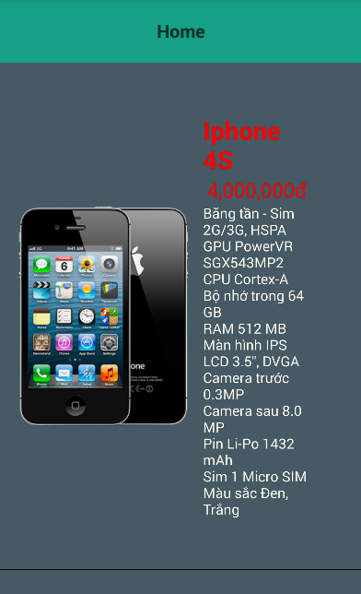

*Image3 :Home page*

### Functional Requirements

|  |  |  |  |
| --- | --- | --- | --- |
| **Name** | **Description** | **Action** | **Response** |
| Home page | Include:   * 1 Image * List view * 3 Text | N/A | N/A |
| Image | Contains the image of the application | N/A | N/A |
| Text “Title” | Product’s name | N/A | N/A |
| Text “Price” | Product price | N/A | N/A |
| Text “Description” | Product introduction | N/A | N/A |

## **Feature/Component #4: Detail page**

### User Interfaces

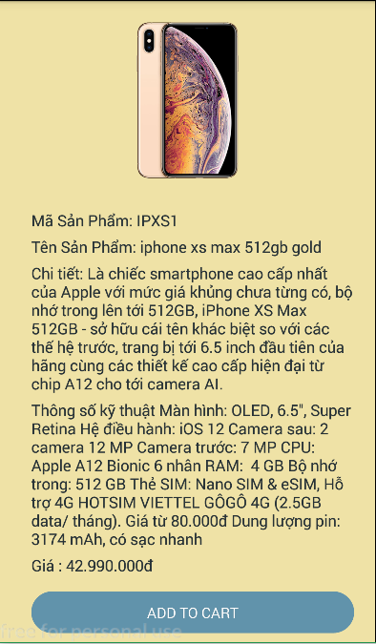

*Image4: Detail page*

### Functional Requirements

|  |  |  |  |
| --- | --- | --- | --- |
| Item | Description | Action | Response |
| *Detail page* | Include:   * Image * 4 Text * 1 Button | N/A | N/A |
| Image | Contains the image of the application | N/A | N/A |
| Text “product code” | Display product code | N/A | N/A |
| Text “product name” | Display product name | N/A | N/A |
| Text “product detail” | Display product detail | N/A | N/A |
| Text “product price” | Display product price | N/A | N/A |
| Button ”Add to card” | Allows users add product to card | Click | Application will specify a you want to add the product or not.  If agree will report “Add to card”  Otherwise go back to the previous page |

## **Feature/Component #5: User info page**

### User Interfaces

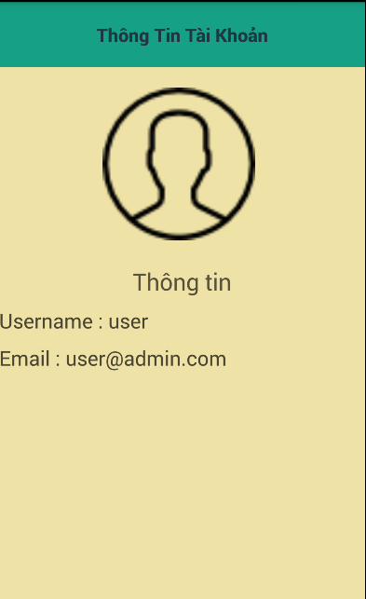

*Image5: User info page*

### Functional Requirements

|  |  |  |  |
| --- | --- | --- | --- |
| **Name** | **Description** | **Action** | **Response** |
| User info page | Include:   * 1 Button * Image * 3 Text | N/A | N/A |
| Button “user info” | Name user info | N/A | N/A |
| Image | contains user information image | N/A | N/A |
| Text “ information “ | Display information | N/A | N/A |
| Text “ user name “ | Display user name | N/A | Will display the user name from database |
| Text “ Email “ | Display email | N/A | Will display the user email from database |

## **Feature/Component #6: Logout page**

### User Interfaces

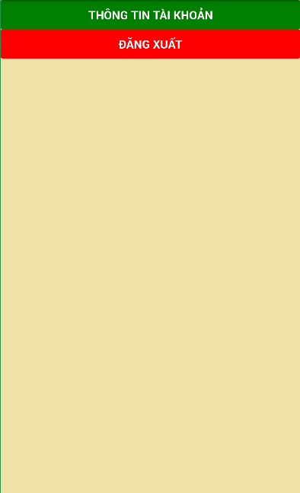

*Image6: Logout page*

### Functional Requirements

|  |  |  |  |
| --- | --- | --- | --- |
| Item | Description | Action | Response |
| Logout | Include:   * 2 Button | N/A | N/A |
| Button “User Information” |  | Click | Display user information page |
| Button “Logout” |  | Click | Back to login page |

***---------- End of Document ----------***